LC Module
Main Database
Cost Center

LC Setup

Main Transactions
LC Transaction

Table of Contents

Requirements Analysis
Systems Characteristics
Integration to Other Modules
User Pre-Requisites
Getting Started
Setups
- Cost Center File ………………………………………………………………… …………………………………….
- LC Setup ………………………………………………………………………………………………………………..
Transactions
- LC Transaction: Recording Receipts in Cash ……………………………………………………………….
Reports
- Cost Centre Listing …………………………………………………………………………………………………..
- LC Master Listing ………………………………………………………………………………………………………
- Supplier Listing ………………………………………………………………………………………………………..
- Document ……………………………………………………………………………………………………………….
- Transaction Log ……………………………………………………………………………………………………….
- Landed Cost …………………………………………………………………………………………………………….
Utility Tools
- Posting Process …………………………………………………………………………………………………………
- Un-Posting Process……………………………………………………………………………………………………..
Requirements Analysis
Systems Characteristics
Integration with Other Modules

LC Management Module is linked with the following FCL modules:

LCM

GL
Dependency Diagram
- Financial Module - GL

Relationship with Financial Module

- An LC Setup entry updates FCL Financial Module with a brand new account head with the LC number specified; which is then used to pay off the LC voucher made through LC Transaction

User Pre-Requisites
Getting Started

Setup
_______________________________________________________________________________

The FCL LC Module Setup files are data entry screens for the following main database entities:

- Cost Center
- LC Setup

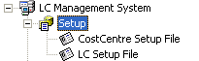 | 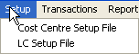

In the subsequent pages, each Setup entry is described briefly with the help of screen-shots.
Cost Center File
_______________________________________________________________________________

Description
A simple Code-Name data entry form for keeping record of different charging areas. When transactions made with reference to a cost center helps a financial module track financial activities cost center wise.

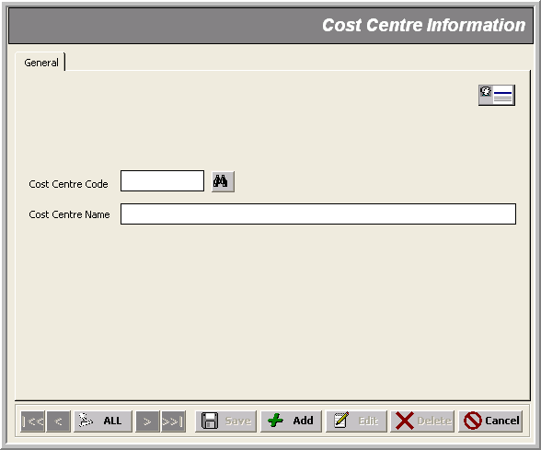
* Cost Center Name (@³⁰)

* Cost Center Code (@@)
LC Setup File _______________________________________________________________________________

Description
A simple data entry form for keeping record of different LC numbers along with all kinds of details.

Note that:
- An LC entry updates FCL Financial Module with a brand new account head with the LC number specified; which is then used to pay off the LC

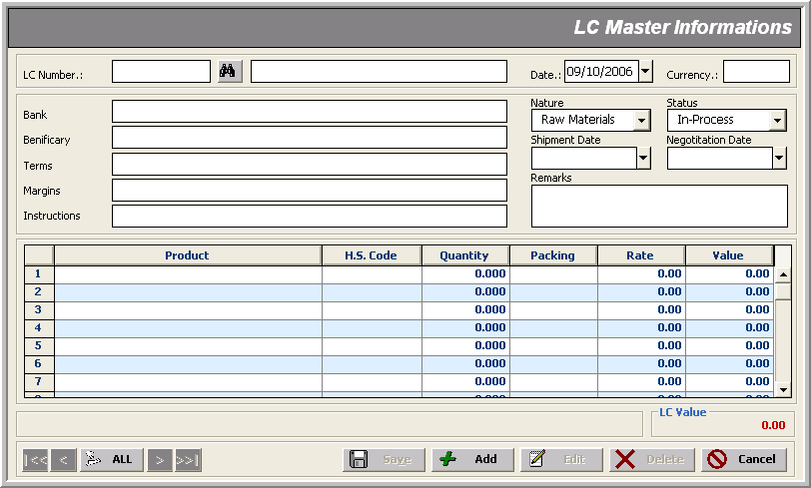

Transactions
_______________________________________________________________________________
The only transaction in the FCL LC Module is there to create a voucher to be settled in the FCL Financial Module:

- Recording LC Payable– LC Transaction

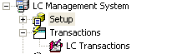 | 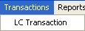

LC Transaction _______________________________________________________________________________
Use case: Recording LC Payable Details

Description
This form helps create payment vouchers for FCL Financial Module with the following mandatory data entry:

- Voucher No (Auto generated in ‘yymmnnnn’ format)
- Voucher Date
- LC Number (to be used as Credit Account)
- Journal entries against charging areas (Cost Center)

Optional information includes:
- Party Reference
- Remarks
- Bill No and Bill Date

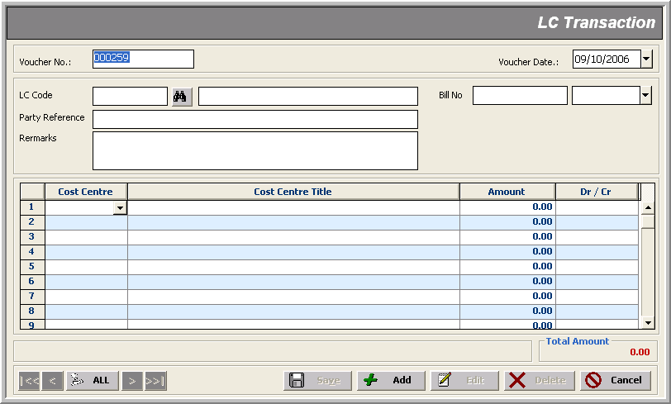
Debit/Credit
* Voucher No
* Cost Center
* Voucher Date
* LC Number
Party Reference
Amount
Bill Info

Reports
_______________________________________________________________________________

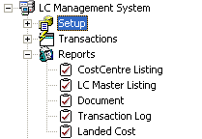 | 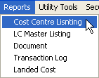

Utility Tools
_______________________________________________________________________________

Utility Tools cover periodic processes within a closing schedule life-cycle, such as:

- Posting
- Un-Posting

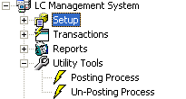 | 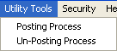

Posting Process _______________________________________________________________________________

Description
Posting Process is performed to Post transactions in non-editable mode to tag them as ‘confirmed’ transactions. It performs the following task:

- Locks all transactions for editing

Here’s how it proceeds:
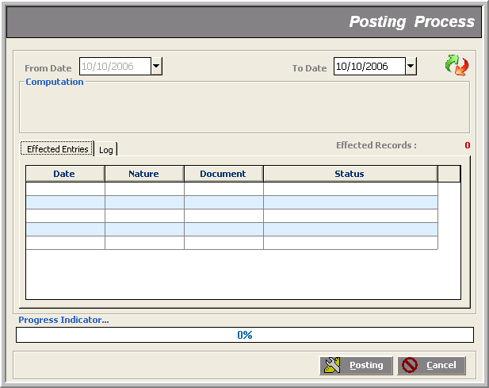

On finding un-posted data, a message box pops up asking for confirmation to go on. Next window shows the scan progress for un-posted transactions. Finally, a message box flags the end of process.

Un-Posting Process _______________________________________________________________________________

Description
Un-Posting Process performs the following jobs:

- If document no.’s range is provided; it ‘unlocks’ those documents for editing; other wise only first task is done

Note that:
- In Un-Posting Process, ’To Date’ is disabled meaning that the process ‘Un-Posts’ only those transactions that were recorded from ‘From Date’ until NOW
- This impacts the relevant reports in that now you can view only those transaction records that were made until the ‘From Date’ specified (all those ‘Posted’ to date)

Here’s how it proceeds:
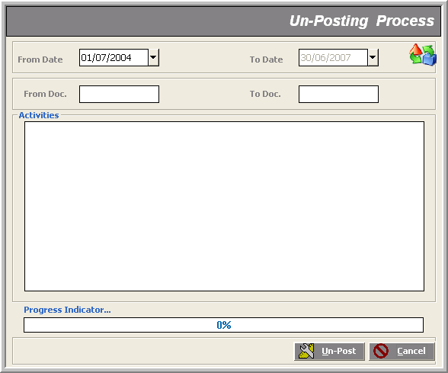

The process signals its successful finish giving a short description of the ‘Activities’ in the text area. If we had given document numbers’ range, the process would have ‘unlocked’ those documents for editing

